Refined Scattering Processes
Aim: To better represent the scattering processes that occur in electron neutral collisions.
Current State: Previously assuming isotropic scattering on ‘pure elastic collisions’ or alternatively ignoring scattering altogether.

Data Available
Key References:
Itikawa and Mason (2005) - Cross Sections for Electron Collisions with Water Molecules
Cho et al (2004) - Measurements of elastic electron scattering by water vapour extended to backward angles
Faure et al (2004) - Low-energy electron collisions with water: elastic and rotationally inelastic scattering
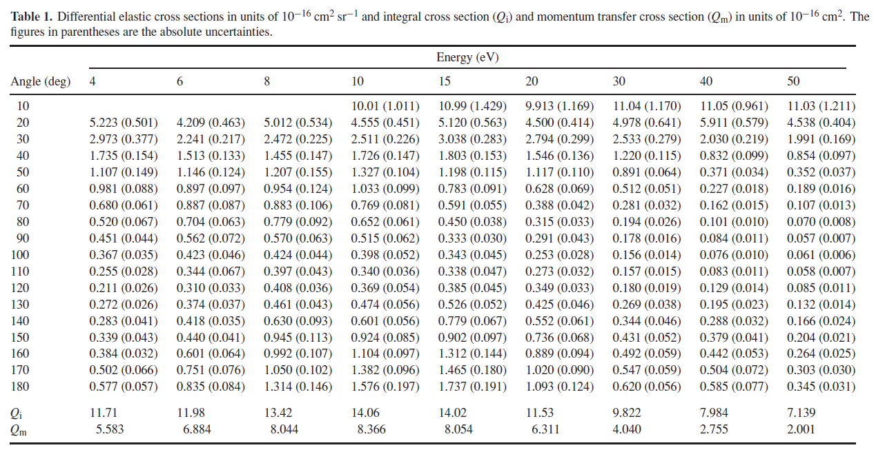
Figure 1. Cho et al Table 1
Cho et al provide vibrationally elastic differential cross sections for E > 4eV. This includes all rotational transition processes (e.g. J = 0 ->1, J= 0->0, etc. ) which have small associated energy losses (dE = 0.004eV …).
Faure et al (2004) provide diff XSecs for low energy vibrationally elastic scattering. Also shows the breakdown between rotational transitions. Particularly pure elastic collision (j=0->0).

0.25eV | 1eV | 4eV with data from Cho et al (2004)
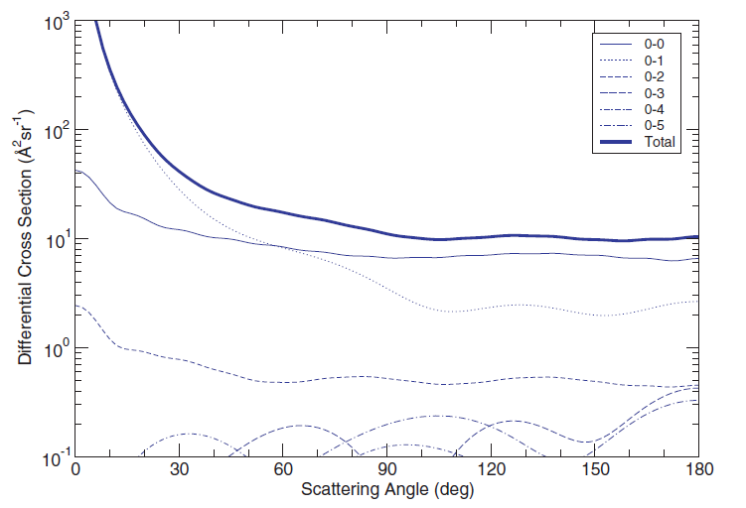 | 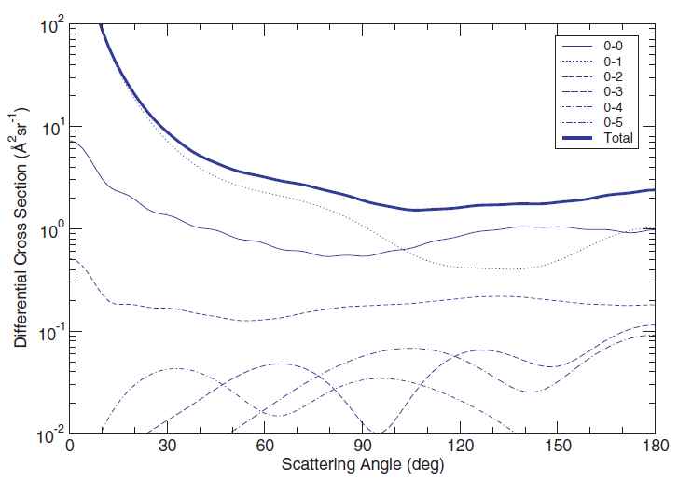 | 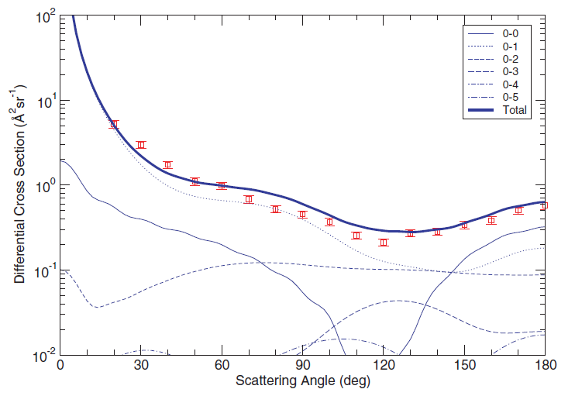

Scattering is not only from pure elastic collisions, the rotational collisions also contribute significantly towards the angular redistribution of particles (see 4eV plot Faure et al).
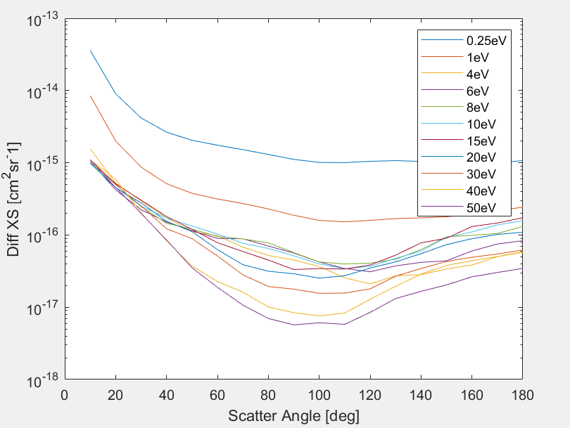
Figure 2 Differential cross sections from Cho et al(2004) and Faure et al (2004). For the Cho et al 4,6,8eV diff XS at 10 degrees the DXS at 20 degrees has been multiplied by 3, 2.5 and 2 respectively.
Plan: separate the energy loss and scattering processes from the rotationally inelastic collisions. All scattering is treated as pure elastic but increase elastic scattering XS so it includes both elastic and rotationally inelastic scattering.
Assumption: elastic scattering collisions with a small angle change ~0deg are equivalent to no collision occurring. Therefore, we can neglect these collisions. – This helps as there is no data available at 0deg and the extrapolation to low angles is less clear.
Method:
Elastic collisions will occur in two steps:
- Determine whether an elastic collision occurs
- Determine the scattering angle required
Step 1: This will be determined with the total cross section at the given energy. The total cross section is determined by integrating the differential XS over the solid angle from 10 deg to 180. The resulting XS is shown in Fig 3.
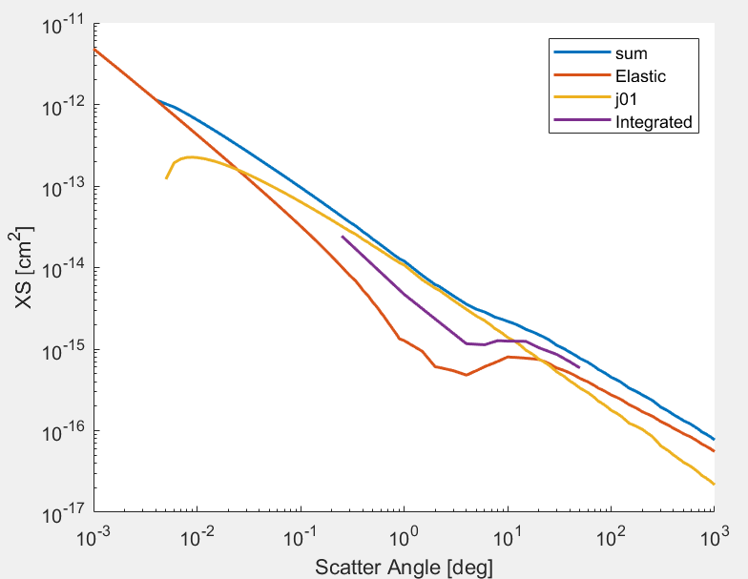
Figure 3. Red - Pure elastic XS (Itikawa and Mason, 2005, Table 7). Yellow - J = 0->1 rotational transition. Purple - Integrated diff XS from Figure 2. Blue - Sum of elastic and rotational cross section.
Cross section needs to be extended beyond the data range from Faure et al and Cho et al. At limits XS is approximately purely elastic, so tend to these at high energies (see below).
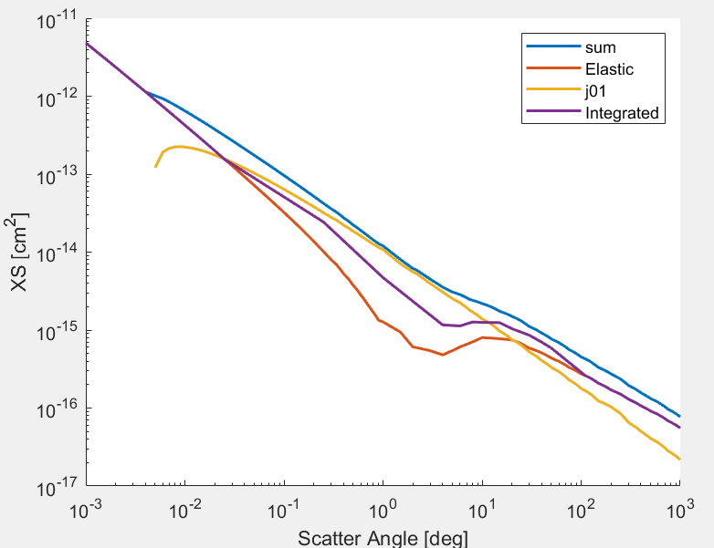
Step 2:
Once it has been determined that a collision occurs, the change in the scattering angle must be determined.
For each energy, the cumulative distribution function is calculated from 10 to 180 degs. Values calculated at 10 degree intervals.
The cdf is interpolated to the energy of the particle in question.
A random number is generated and is interpolated between the cdf values to give the particle scattering angle. This gives the change in theta.
Second random number determines the dphi from a tophat function between 0 and 2pi.
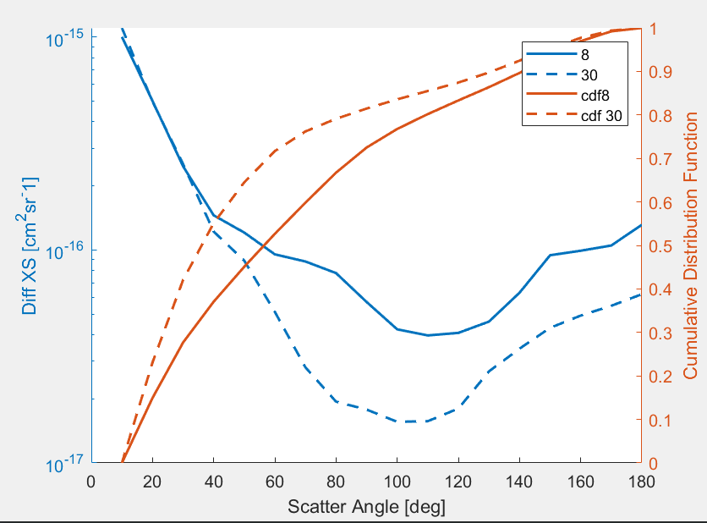

The diff XS is assumed as isotropic at 0eV, and beyond 50eV the cdf is assumed as constant. This may slightly overestimate the scattering at high energies.

Files Required:
New total XS file
Scattering cdf file

